# Title:

The Role of AI in Healthcare Enterprises: Opportunities, Challenges, and Risks

## **Abstract**

The study looks at how incorporating artificial intelligence (AI) into healthcare might improve both operational effectiveness and patient care. Through a thorough literature review, it investigates the advantages, challenges, and dangers of adopting AI. The study aims to change the delivery of healthcare by using AI technology such as clinical decision support systems and diagnostic algorithms in real time. Addressing issues like algorithmic bias and data privacy, it places a strong emphasis on interdisciplinary collaboration and explainable AI (XAI) concepts. It also emphasises how healthcare workers must receive AI education and training in order to assure its responsible deployment. To fully use AI in healthcare organisations, research and development must continue despite barriers.

**Key Terms**: Artificial Intelligence (AI), Machine Learning (ML), Diagnostic Algorithms, Real-time Clinical Decision Support Systems, Predictive Analytics, Healthcare Enterprises, Opportunities, Challenges, Risks

## **1. Introduction**

In the fields of science, engineering, and enterprise, AI is becoming increasingly important. This survey paper explores the important role of AI in the healthcare sector. The aim of the literature review is to thoroughly examine the role of AI in healthcare enterprises, its opportunities, challenges, and risks. The driving force behind this review is the growing integration of AI technology in healthcare settings. The study conducts a scoping review to map the current state of AI in healthcare, identifying gaps and synthesising insights from many sources. Each component of this paper covers an important facet of AI integration in healthcare. For instance, how it affects healthcare delivery, how AI and humans interact, security issues, new developments, and practical applications. This methodical approach provides an in-depth understanding of the complex role that AI serves in healthcare enterprises, guiding future study and application in this rapidly growing area.

## **2. Impact of AI on Healthcare Delivery**

AI has received a lot of attention in the healthcare industry because of its potential to improve diagnosis accuracy and treatment planning. Tables 2 and 3 provide insight on how AI is affecting healthcare delivery and solutions.

Table 2 & 3: Addressing the Cons of Adopting AI Tech Benefits of Adopting AI Tech.

AI systems analyse large medical datasets using complex algorithms and methods of machine learning to provide insights that could have been overlooked by human practitioners. AI-powered diagnostic systems offer exceptional precision when compared to conventional diagnostic approaches, such as manual interpretation by physicians or laboratory testing performed by staff. Figure 1 illustrates the distinct advantages of AI-based urine analysis over traditional methods, highlighting its potential to transform healthcare diagnostics [1].

Figure 1: Comparison between AI-based Urine analysis and traditional methods (Shukla et al. 2023)

AI-powered diagnostic systems offer enhanced precision, leading to more accurate diagnoses, personalised treatment recommendations, and improved patient care. They also streamline patient flow, optimise image processing, reduce scan time and radiation dose, and serve as decision aids in image interpretation [2].These systems are more capable of diagnosing problems than humans are at finding complex patterns in medical data. However, issues like algorithmic bias and possible misdiagnosis may occur. AI algorithms can display biases that impact diagnostic results despite being accurate [3]. Therefore, strict validation and oversight are necessary to reduce hazards.

Furthermore, incorporating AI affects many areas of scientific, technical, and business domains and goes beyond clinical applications. In terms of science, AI offers opportunities to expand medical research through improved data processing and pattern identification. By identifying complex relationships in large datasets, AI accelerates the discovery for new cures and treatments while expanding the scope of those conditions [4]. Technically speaking, AI integration optimises resource allocation and streamlines operations within diagnostic systems [5], as illustrated in figure 2. This reduces the amount of time and effort needed for diagnosis and allows medical staff to concentrate on decision-making. From a business perspective, the adoption of AI technologies improves service delivery. Healthcare companies can distinguish themselves in the market by offering more precise and effective diagnostic services through the use of AI-powered solutions. This, in turn, is expected to increase speed, cost, capacity, quality, and consistency [6]. Overall, the integration of AI enables healthcare enterprises to excel in a data-driven and digital environment, with the potential to significantly enhance both patient care and operational effectiveness.

Figure 2: Healthcare Workflow With(out) AI

As seen in Figures 3 and 4, AI-driven chatbots and virtual assistants have emerged as important resources for helping and interacting with patients. They improve communication and resource access by providing effective monitoring and appointment booking services and tailored health advice [7]. Figure 5 lists medical conditions handled by bot, while Figure 6 shows bot responses. Healthcare organisations like the NHS have embraced these technologies. But when increasing patient involvement and access, issues with security, privacy, trust, and empathy come up and need to be taken into consideration. Strong privacy regulations must be implemented to protect patient data. AI models that are continuously trained also become more responsive and have the ability to handle empathy-related problems better [8]. Including human oversight guarantees that complicated problems are handled correctly. It strikes a balance between efficiency, empathy, and building patient trust. In conclusion, although these technologies have a lot to offer, it is imperative to address privacy and empathy concerns in order to fully reap the potential of these tools while upholding patient confidentiality and confidence.

Figure 3: Virtual Assistants and Chatbots in Healthcare

Figure 4:The Roborto Conversational Interface

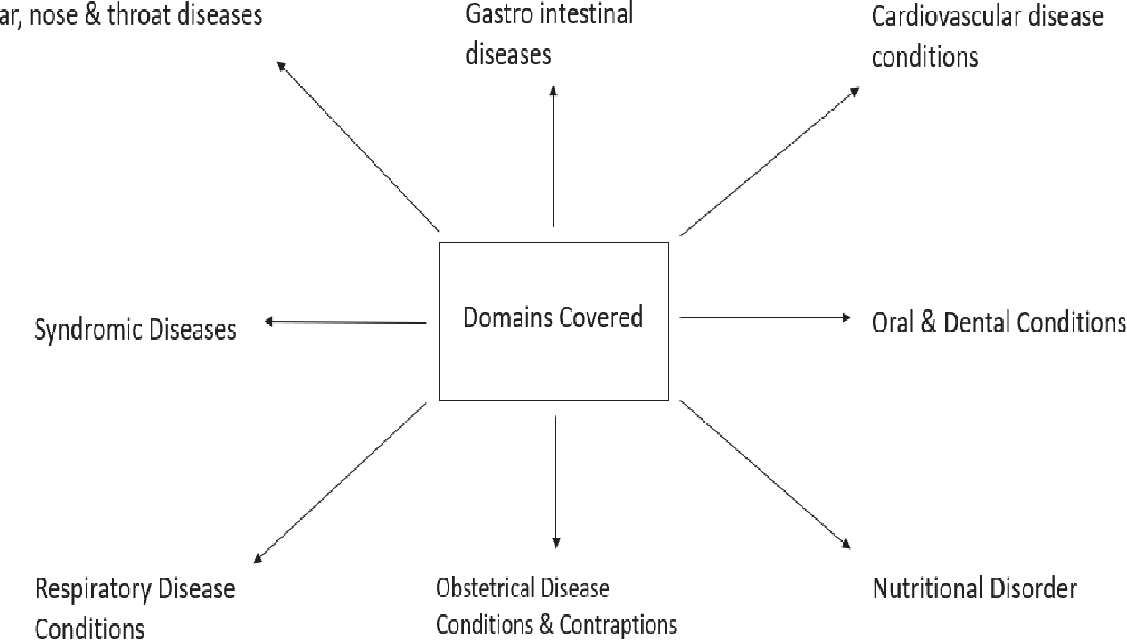

Figure 5: List of medical illnesses covered in bot **[7]**

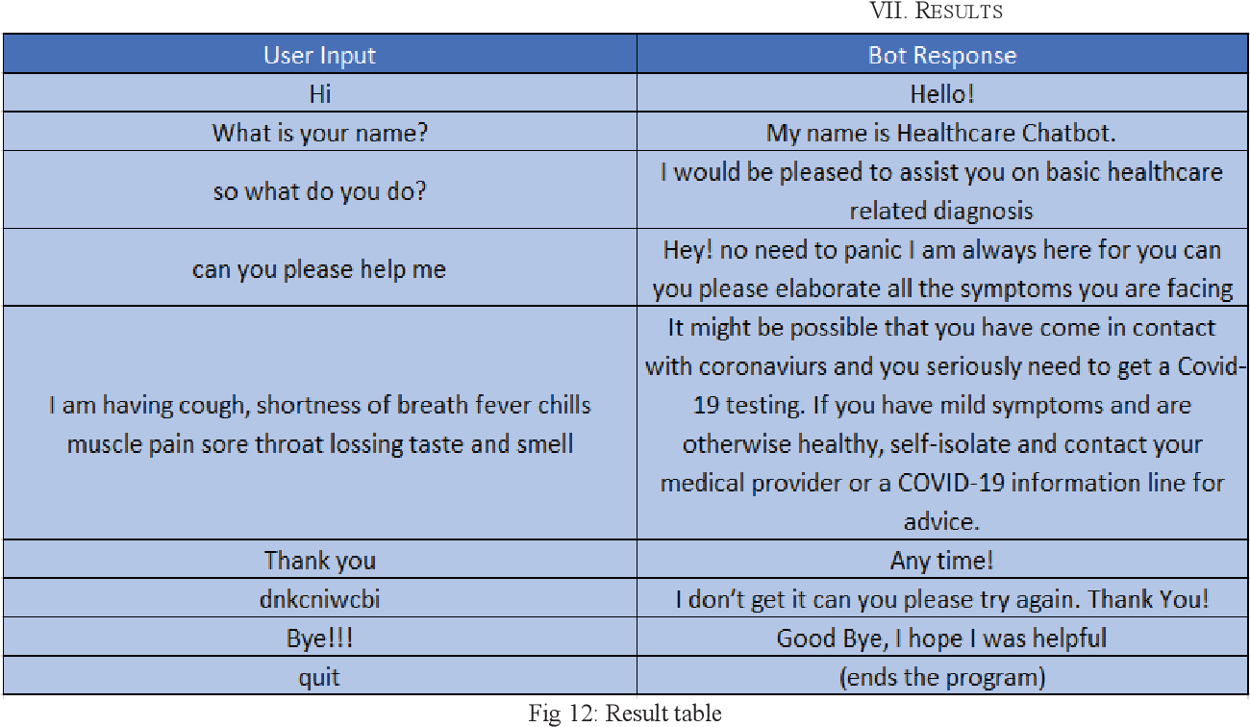

**Figure 6: Bot responses[7]**

## **3. Human-AI Dynamics in Healthcare**

AI integration in healthcare raises concerns about job displacement and overshadowing human expertise, leading to lower adoption rates compared to other industries [9]. But at the heart of this change is the symbiotic relationship between AI and humans. Here, AI enhances rather than replaces human abilities [10]. This partnership appears in the delivery of healthcare, where practitioners are given AI-driven insights through the use of chatbots to communicate with patients. Despite initial perceptions of competition, the true potential lies in collaborative partnerships, which allow organisations to reap AI benefits while mitigating risks [11]. Understanding the various forms of AI integration in healthcare is essential. Organisations that embrace collaboration and symbiosis can create opportunities, address challenges, and handle complications associated with AI deployment. This section thoroughly examines these processes, providing insights into AI's future in healthcare organisations.

In the field of Human-AI dynamics in healthcare, three key methods emerge: Human-in-the-Loop Systems, Explainable AI (XAI), and Interdisciplinary Collaboration. Each method provides a unique approach to leveraging the symbiotic relationship between humans and AI in healthcare settings.

Human-in-the-Loop Systems combine human expertise and AI capabilities, allowing humans to provide feedback during decision-making [12] Unlike fully automated systems, they combine AI automation with human control, balancing AI insights with clinical discretion. This strategy merges algorithmic and human-centric methods, enhancing interpretability, reliability, and adaptability. It could alleviate workforce shortages, aid busy medical professionals, and enhance healthcare quality [13]. However, obstacles such as complexity and decision-making delays may arise, requiring constant training and workflow optimisation to ensure smooth incorporation into clinical practice. Deploying Human-in-the-Loop Systems in enterprise applications increases healthcare professionals' trust in AI guidance while also addressing the challenges outlined above through human-AI collaboration.

XAI seeks to make AI algorithms more transparent and interpretable, promoting trust and collaboration between staff and AI systems [14]. Unlike black-box models, XAI offers insights into AI decision-making [15] hence increasing confidence and regulatory compliance. Deploying XAI ensures that AI is used ethically while also meeting regulatory criteria and patient expectations. However, there are challenges such as model complexity and trade-offs between explainability and performance. These can be resolved by simplifying models and offering clearer explanations.

Interdisciplinary collaboration involves working with healthcare experts, AI developers, ethicists, policymakers, and others to address difficult healthcare concerns. This method invites multiple viewpoints, which drives innovation and solving issues. Other benefits include creativity, and stakeholder participation. Communication challenges and competing priorities can hinder teamwork, potentially contributing to up to 70% of reported adverse events [16]. Building a collaborative culture, providing clear communication lines, and resources can help overcome these issues.

AI integration in healthcare supports collaborative solutions by using strategies like human-in-the-loop systems, XAI, and interdisciplinary collaboration, increasing discovery and tackling healthcare challenges. Leveraging Human-AI dynamics enables enterprises to improve patient care and healthcare environments by embracing collaboration and addressing difficulties, thereby maximising AI's trust, transparency, and innovation.

## **4. Education and Training in AI for Healthcare Professionals**

Education and training in AI for Healthcare Professionals is critical for equipping the workforce to properly use AI technology in healthcare [17]. These programmes include a variety of approaches, such as medical learning experiences, simulation training, and personalised learning materials, all aimed at improving clinical decision-making abilities and promoting evidence-based practice. Furthermore, AI-driven training programmes assist professionals in staying up-to-date on the newest medical developments [18]. This provides continual professional development in a fast changing healthcare field. Employees' involvement in AI integration efforts can ease worries about potential job displacement by emphasising that AI cannot function without qualified staff.

However, as depicted in table X, introducing AI into education and training programmes presents challenges such as curriculum redesign and faculty training. Ensuring system stability, scalability, and compliance requires Machine Learning Operations (MLOps) procedures [19] despite resource constraints, technological difficulties, and regulatory requirements. However, investing in AI education for healthcare professionals is critical for building a qualified workforce [20].

**Table X: Integration of AI in Healthcare Enterprises: Benefits and Ethical Considerations.**

## **5. AI Security and Surveillance in Healthcare**

Building on the previous chapter, this section explores the need for human-AI dynamics in healthcare security and surveillance as well as common concerns.The use of AI technology in surveillance and security within healthcare, like advanced video analytics systems created by GE Healthcare, offers a substantial leap in threat detection and patient safety monitoring. However, despite AI's ability to quickly evaluate large datasets for anomaly detection, incidents such as the WannaCry scandal in 2017 and issues discovered in IBM's Watson for Oncology system in 2018 highlight the significance of human oversight in correcting AI shortcomings. The WannaCry scandal exposed weaknesses in out-of-date software systems in 150 countries [21], requiring human intervention in addition to AI support to successfully prioritise and apply timely software updates.

Similarly, defects in IBM's Watson for Oncology system's cancer treatment recommendations highlighted the importance of human experience in verifying and validating AI-generated ideas before integrating them into patient care. To address these issues, healthcare organisations must prioritise continual AI algorithm training and development while encouraging collaboration between AI systems and staff members [22]. This can improve security protocols, response times, and patient privacy and safety protection.

Figure 5 shows how AI applications in surveillance and security provide considerable benefits to healthcare facilities. These systems, which are used by major organisations like Siemens, Philips Healthcare, and ADT Healthcare [23], include behaviour recognition features and anomaly detection algorithms to quickly execute security policies and respond to potential threats. Despite AI's outstanding abilities in data processing and anomaly detection, worries remain about its ability to manage complicated scenarios and ensure optimal system performance. As a result, human oversight continues to be critical in addressing errors, strengthening security standards, and effectively protecting patient safety. Robust testing procedures, constant monitoring mechanisms, and feedback loops can help AI systems perform better and adapt more easily [24]. Furthermore, increasing collaboration between AI experts and domain-specific professionals, as well as regular updates and ethical considerations, can help AI enhance its ability to manage security risks while providing high-quality patient care.

**Figure 5: 9 Companies Offering AI Surveillance**

## **6. AI Trends, Opportunities, and Challenges**

In recent years, the application of AI and machine learning (ML) in healthcare has resulted in a significant change. The change is primarily caused by advances in technology and data analysis approaches [25]. Deep learning (DL) has revolutionised the management and interpretation of vast medical data with precision and efficiency.

One area where the impact of AI is particularly profound is in clinical oncology, where it is transforming the way diseases are detected and treated. For instance, AI algorithms are delving deep into the detailed molecular mechanisms underlying cancer, enhancing the understanding of the disease and aiding in the development of targeted treatment [26]. Furthermore, initiatives such as precision oncology leverage AI to customise treatment plans for individual patients based on genetic variations within tumours, leading to improved treatment effectiveness and patient outcomes [27].

But AI's influence extends beyond oncology into various other medical domains, including drug discovery and medical imaging. Projects like the Exascale Compound Activity Prediction Engine (ExCAPE) use AI to analyse large molecular datasets, expediting the identification of potential drug candidates[26]. Recent advancements in medical imaging have also seen the integration of AI-driven technologies [28], as depicted in Figure 6 . These innovations enhance diagnostic accuracy by detecting even the most subtle abnormalities in medical images.

**Figure 6: Illustration of different types of dermoscopic skin lesions where (a) Nevi (b) Melanoma (c) Basal Cell Carcinoma (d) Actinic Keratosis (e) Benign Keratosis (f) Dermatofibroma (g) Vascular Lesion (h) Squamous Cell Carcinoma** [29]

Moreover, AI-powered smartphone applications like SkinVision have emerged as valuable tools in the early detection of skin cancer. By analysing photographs of skin lesions, these apps provide users with prompt and accurate assessments, enabling timely intervention and treatment [30]. Overall, the integration of AI into healthcare is reshaping the landscape of medical practice, driving advancements in disease diagnosis, treatment personalisation, and patient care.

In surgical practice, AI plays an important role in enhancing decision-making processes and improving surgical outcomes. ML models, as highlighted by [26], assist surgeons in predicting high-risk cancer lesions, thereby facilitating the development of personalised treatment plans and reducing unnecessary procedures. Moreover, the analysis of patient data through AI-driven algorithms, as emphasised by Goyal et al. (2019), aids in identifying optimal surgical approaches, resulting in improved patient outcomes. Another promising area is the development of AI-controlled conversational agents or chatbots for providing health advice [31].

While the integration of AI into healthcare holds potential to revolutionise the field by extracting insights from vast digital data, it also presents ethical concerns. The most common among these is the risk of AI inaccuracies and potential data breaches, exposing patients to harm within healthcare systems. To address these challenges, robust governance frameworks are essential to ensure the ethical integration of AI into medical practice. These frameworks safeguard against harm and address various ethical challenges present in AI-driven healthcare [32]. Challenges include obtaining informed consent for data usage, ensuring the safety and transparency of AI algorithms, mitigating biases, promoting fairness, and preserving patient data privacy.

Proactive policy making is necessary to overcome these ethical issues effectively and to ensure responsible AI implementation in healthcare settings [33]. Additionally, concerns persist regarding algorithmic transparency and accountability, as AI systems may operate based on unfixed rules and adapt to new behavioural patterns over time. Addressing these concerns is vital for maintaining public trust in AI-driven healthcare solutions. As illustrated in Figure 7, a comprehensive ethical governance framework outlines the strategies and mechanisms necessary for the responsible integration of AI into medical practice.

**Figure 7: Ethical Governance Framework for AI Integration**

According to Panesar et al. (2019), artificial intelligence systems for diagnostic purposes have started to exhibit capabilities that are comparable to those of specialised physicians [34]. Future developments in AI in medicine appear promising: developing intelligent surgical robots, forecasting the results of gene therapy, and optimising stem cell therapy are some potential uses [35]. These advancements demonstrate how crucial ethical AI integration will continue to be in determining the course of medical history.

## **7. AI-Powered Solutions in Healthcare Enterprises**

The healthcare landscape is rapidly evolving with the emergence of AI-powered technologies including diagnostic algorithms, electronic health record (EHR) systems, and real-time clinical decision support systems. These technologies use advanced machine learning (ML) and deep learning (DL) approaches to improve multiple aspects of healthcare delivery [36], such as diagnosis and treatment planning. Integrating AI technologies into healthcare operations is becoming increasingly important as enterprises begin digital transformation journeys to increase productivity and reduce costs. For example, implementing AI-powered solutions simplifies processes, lowers manual workload, and optimises resource utilisation [37], resulting in increased operational efficiency and cost-effectiveness. In this dynamic context, using development operations (DevOps) methodologies is critical for optimising the development and deployment of AI-driven solutions within healthcare enterprises.

Diagnostic algorithms powered by AI help healthcare practitioners make precise diagnoses, providing a more efficient and objective alternative to traditional, manual diagnostic processes [38]. The challenges involved with these algorithms include maintaining accuracy, protecting data privacy, and ensuring regulatory compliance. Smooth integration with existing healthcare systems requires compatibility, interoperability, and stringent validation procedures. Collaboration among healthcare specialists, data scientists, and AI developers is required to create algorithms that meet clinical objectives while also ensuring patient safety and regulatory compliance.

EHR systems allow healthcare providers to electronically store, manage, and retrieve patient health information, which speeds up processes and improves patient care management. Various study methods exist for processing EHR data, with DL being the most accurate, as shown in Table X [38] . While EHR systems have advantages over paper-based records, including increased data accessibility and decision support capabilities [39], data security breaches and interoperability difficulties can hinder their adoption and efficiency in healthcare organisations.

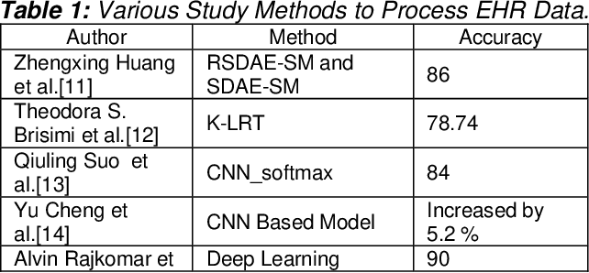

Table X: Various Study Methods to Process EHR Data [38]

Real-time clinical decision support systems use AI algorithms to analyse patient data and make evidence-based recommendations during patient encounters [40], with the goal of improving clinical decision-making and patient safety. Despite their potential benefits, issues such as algorithmic bias and resistance from healthcare staff may impede the successful implementation of these systems in healthcare enterprises.

Integrating predictive analytics and AI-powered scheduling systems can improve operational efficiency and patient satisfaction by optimising resource allocation and shortening wait times [41]. However, difficulties with data quality and reluctance to change must be addressed to maximise the potential of these systems. Each AI-powered solution has its own set of advantages and disadvantages, requiring healthcare organisations to handle issues such as reliability, data privacy, regulatory compliance, interoperability, and user acceptance [42]. Adopting a collaborative approach that combines AI technologies and DevOps principles allows healthcare businesses to overcome these obstacles and improve patient and provider outcomes. Table 5 looks at AI-Powered Healthcare Innovations, with an emphasis on the integration of EHR systems with telemedicine platforms to manage CKD. Improving EHR systems for CKD treatment can improve patient outcomes by allowing for remote consultations, quicker paperwork, and early problem detection via advanced analytics integration, crucial for slowing disease progression [43].

Overall, while AI-powered solutions have the potential to improve healthcare delivery, solving dependability, data protection, and user acceptance issues is critical. Collaborative use of DevOps methods helps to overcome these issues, resulting in greater patient and provider outcomes.

**Table 5: AI-Powered Healthcare Innovations: Recommendations and Future Directions**

## **8. Conclusion**

Finally, integrating AI into healthcare organisations has enormous potential for revolutionising patient care and operational efficiency. AI-powered diagnostic algorithms, real-time clinical decision support systems, and predictive analytics can help healthcare organisations improve diagnostic accuracy, expedite operations, and improve patient outcomes. However, this transition brings along a number of obstacles, including algorithmic bias, data privacy concerns, and the need for interdisciplinary collaboration. Healthcare enterprises can overcome these obstacles by implementing methods such as Human-in-the-Loop Systems, XAI, and encouraging interdisciplinary collaboration. Furthermore, education and training programmes in AI for healthcare workers, strong AI security and monitoring mechanisms, and proactive policymaking are required to ensure responsible AI integration and address ethical problems. Despite these challenges, this paper emphasises AI's transformative influence in healthcare and the importance of ongoing research, innovation, and collaboration to maximise benefits while limiting dangers.

# **References**

[1]

V. K. Shukla *et al.*, “Transforming Disease Diagnosis and Management: a Comprehensive Review of AI-Driven Urine Analysis in Clinical Medicine,” *Engineered Science*, vol. Volume 26 December 2023, no. 0, p. 1009, Nov. 2023, Accessed: Mar. 10, 2024. [Online]. Available: https://www.espublisher.com/journals/articlehtml/engineered-science/10.30919-es1009

[2] C. N. Ladefoged, F. L. Andersen, and L. Højgaard, “[Artificial Intelligence for Diagnostic imaging],” *Ugeskrift for Laeger*, vol. 182, no. 13, p. V10190563, Mar. 2020, Accessed: Mar. 30, 2024. [Online]. Available: <https://pubmed.ncbi.nlm.nih.gov/32285782/>

[3] D. C. Hague, “Benefits, Pitfalls, and Potential Bias in Health Care AI,” *North Carolina Medical Journal*, vol. 80, no. 4, pp. 219–223, Jul. 2019, doi: https://doi.org/10.18043/ncm.80.4.219.

[4] T. Pereira *et al.*, “Sharing Biomedical Data: Strengthening AI Development in Healthcare,” *Healthcare*, vol. 9, no. 7, p. 827, Jun. 2021, doi: <https://doi.org/10.3390/healthcare9070827>.

[5] T. R. Undru *et al.*, “Integrating Artificial Intelligence for Clinical and Laboratory Diagnosis - a Review,” *Maedica*, vol. 17, no. 2, pp. 420–426, Jun. 2022, doi: https://doi.org/10.26574/maedica.2022.17.2.420.

[6] J. Herrle, “Artificial Intelligence in Health Care,” *Canadian Journal of Optometry*, vol. 80, no. 4, pp. 67–68, Nov. 2018, doi: https://doi.org/10.15353/cjo.80.239.

[7] P. Kandpal, K. Jasnani, R. Raut, and S. Bhorge, “Contextual Chatbot for Healthcare Purposes (using Deep Learning),” *2020 Fourth World Conference on Smart Trends in Systems, Security and Sustainability (WorldS4)*, Jul. 2020, doi: <https://doi.org/10.1109/worlds450073.2020.9210351>.

[8] E. Bagheri, P. G. Esteban, H.-L. Cao, A. D. Beir, D. Lefeber, and B. Vanderborght, “An Autonomous Cognitive Empathy Model Responsive to Users’ Facial Emotion Expressions,” *ACM Transactions on Interactive Intelligent Systems*, vol. 10, no. 3, pp. 1–23, Nov. 2020, doi: https://doi.org/10.1145/3341198.

[9] A. Goldfarb, B. Taska, and F. Teodoridis, “Artificial Intelligence in Health Care? Evidence from Online Job Postings,” *AEA Papers and Proceedings*, vol. 110, pp. 400–404, May 2020, doi: https://doi.org/10.1257/pandp.20201006.

[10] B. Meskó, G. Hetényi, and Z. Győrffy, “Will Artificial Intelligence Solve the Human Resource Crisis in healthcare?,” *BMC Health Services Research*, vol. 18, no. 1, Jul. 2018, doi: https://doi.org/10.1186/s12913-018-3359-4.

[11] A. Shuaib, H. Arian, and A. Shuaib, “The Increasing Role of Artificial Intelligence in Health Care: Will Robots Replace Doctors in the Future?,” *International Journal of General Medicine*, vol. Volume 13, pp. 891–896, Oct. 2020, doi: https://doi.org/10.2147/ijgm.s268093.

[12] D. Wang *et al.*, “From Human-Human Collaboration to Human-AI Collaboration,” *Extended Abstracts of the 2020 CHI Conference on Human Factors in Computing Systems*, Apr. 2020, doi: https://doi.org/10.1145/3334480.3381069.

[13]

Y. Lai, A. Kankanhalli, and D. Ong, “Human-AI Collaboration in Healthcare: a Review and Research Agenda,” Jan. 2021. Accessed: Mar. 30, 2024. [Online]. Available: https://pdfs.semanticscholar.org/a3ad/dd61082ac7093d9cdc520c8a9ee720c6a374.pdf

[14]

A. Das and P. Rad, “Opportunities and Challenges in Explainable Artificial Intelligence (XAI): a Survey,” *ArXiv*, Jun. 2020, Accessed: Mar. 30, 2024. [Online]. Available: https://www.semanticscholar.org/reader/c483beec0afae8d08f011182460095049025b8d1

[15]

A. M. Antoniadi *et al.*, “Current Challenges and Future Opportunities for XAI in Machine Learning-Based Clinical Decision Support Systems: a Systematic Review,” *Applied Sciences*, vol. 11, no. 11, p. 5088, May 2021, doi: https://doi.org/10.3390/app11115088.

[16]

L. Fewster-Thuente and B. Velsor-Friedrich, “Interdisciplinary Collaboration for Healthcare Professionals,” *Nursing Administration Quarterly*, vol. 32, no. 1, pp. 40–48, Jan. 2008, doi: https://doi.org/10.1097/01.naq.0000305946.31193.61.

[17]

A. H. Sapci and H. A. Sapci, “Artificial Intelligence Education and Tools for Medical and Health Informatics Students: Systematic Review,” *JMIR Medical Education*, vol. 6, no. 1, p. e19285, Jun. 2020, doi: https://doi.org/10.2196/19285.

[18]

W. M. Naqvi, Habiba Sundus, G. Mishra, Ramprasad Muthukrishnan, and P. K. Kandakurti, “AI in Medical Education Curriculum: the Future of Healthcare Learning,” *European Journal of Therapeutics*, Jan. 2024, doi: https://doi.org/10.58600/eurjther1995.

[19]

O. S. Pianykh *et al.*, “Improving healthcare operations management with machine learning,” *Nature Machine Intelligence*, vol. 2, no. 5, pp. 266–273, May 2020, doi: https://doi.org/10.1038/s42256-020-0176-3.

[20]

D. Wiljer and Z. Hakim, “Developing an Artificial Intelligence–Enabled Health Care Practice: Rewiring Health Care Professions for Better Care,” *Journal of Medical Imaging and Radiation Sciences*, vol. 50, no. 4, pp. S8–S14, Dec. 2019, doi: https://doi.org/10.1016/j.jmir.2019.09.010.

[21]

J. M. Ehrenfeld, “WannaCry, Cybersecurity and Health Information Technology: a Time to Act,” *Journal of Medical Systems*, vol. 41, no. 7, May 2017, doi: <https://doi.org/10.1007/s10916-017-0752-1>.

[22]

J. Choi, “AI in Medicine: Need of Orchestration for High-Performance,” *Healthcare Informatics Research*, vol. 25, no. 3, p. 139, 2019, doi: https://doi.org/10.4258/hir.2019.25.3.139.

[23]

I. Bartoletti, “AI in Healthcare: Ethical and Privacy Challenges,” *Artificial Intelligence in Medicine*, vol. 11526, pp. 7–10, 2019, doi: https://doi.org/10.1007/978-3-030-21642-9_2.

[24]

E. Bertino, M. Kantarcioglu, C. G. Akcora, S. Samtani, S. Mittal, and M. Gupta, “AI for Security and Security for AI,” *Proceedings of the Eleventh ACM Conference on Data and Application Security and Privacy*, Apr. 2021, doi: https://doi.org/10.1145/3422337.3450357.

[25]

M. Hemmo Lotem, R. Tzezana, and O. Levtzion-Korach, “[THE IMPACT OF ARTIFICIAL INTELLIGENCE AND BIG DATA ON HEALTHCARE],” *Harefuah*, vol. 160, no. 1, pp. 24–29, Jan. 2021, Accessed: Mar. 08, 2024. [Online]. Available: https://pubmed.ncbi.nlm.nih.gov/33474875/

[26]

M. J. Iqbal *et al.*, “Clinical Applications of Artificial Intelligence and Machine Learning in Cancer diagnosis: Looking into the Future,” *Cancer Cell International*, vol. 21, no. 1, May 2021, doi: <https://doi.org/10.1186/s12935-021-01981-1>.

[27]

A. Dwivedi, S. S. Dwivedi, M. R. Tariq, X. Qiu, S. Hong, and Y. Xin, “Scope of Artificial Intelligence in Medicine,” *Journal of Research in Medical and Dental Science*, vol. 8, no. 3, pp. 137–140, 2020.

[28]

H. Brenes *et al.*, “The Role of Smartphone-Based Applications and Artificial Intelligence Aiding in Screening, Faster Diagnosis and Prevention in Skin Cancer: a Systematic Mini-Review,” *Principles and Practice of Clinical Research*, vol. 9, no. 3, Nov. 2023, doi: https://doi.org/10.21801/ppcrj.2023.93.4.

[29]

M. Goyal, T. Knackstedt, S. Yan, A. Oakley, and S. Hassanpour, “Artificial Intelligence-Based Image Classification for Diagnosis of Skin Cancer: Challenges and Opportunities.,” *arXiv: Image and Video Processing*, Nov. 2019, Available: <https://www.semanticscholar.org/reader/dcfab95dc878c1fa9217495c72085406ed2b6b72>

[30]

Arun Rabindra Katwaroo, Vivek Shanker Adesh, Amrita Lowtan, and Srikanth Umakanthan, “The diagnostic, therapeutic, and Ethical Impact of Artificial Intelligence in Modern Medicine,” *Postgraduate Medical Journal*, Dec. 2023, doi: https://doi.org/10.1093/postmj/qgad135.

[31]

K. Goodman, D. Zandi, A. Reis, and E. Vayena, “Balancing Risks and Benefits of Artificial Intelligence in the Health Sector,” *Bulletin of the World Health Organization*, vol. 98, no. 4, pp. 230–230A, Apr. 2020, doi: https://doi.org/10.2471/blt.20.253823.

[32]

N. Naik *et al.*, “Legal and Ethical Consideration in Artificial Intelligence in Healthcare: Who Takes Responsibility?,” *Frontiers in Surgery*, vol. 9, no. 862322, pp. 1–6, Mar. 2022, doi: https://doi.org/10.3389/fsurg.2022.862322.

[33]

S. Gerke, T. Minssen, and G. Cohen, “Ethical and Legal Challenges of Artificial intelligence-driven Healthcare,” *Artificial Intelligence in Healthcare*, vol. 1, no. 1, pp. 295–336, Jun. 2020, doi: https://doi.org/10.1016/B978-0-12-818438-7.00012-5.

[34]

S. Panesar, Y. Cagle, D. Chander, J. Morey, J. Fernandez-Miranda, and M. Kliot, “Artificial Intelligence and the Future of Surgical Robotics,” *Annals of Surgery*, vol. 270, no. 2, pp. 223–226, Aug. 2019, doi: https://doi.org/10.1097/sla.0000000000003262.

[35]

Z. Ahmad, S. Rahim, M. Zubair, and J. Abdul-Ghafar, “Artificial Intelligence (AI) in medicine, Current Applications and Future Role with Special Emphasis on Its Potential and Promise in pathology: Present and Future impact, Obstacles Including Costs and Acceptance among pathologists, Practical and Philosophical considerations. a Comprehensive Review,” *Diagnostic Pathology*, vol. 16, no. 24, Mar. 2021, doi: https://doi.org/10.1186/s13000-021-01085-4.

[36]

D. Bordoloi, V. Singh, S. Sanober, S. M. Buhari, J. A. Ujjan, and R. Boddu, “Deep Learning in Healthcare System for Quality of Service,” *Journal of Healthcare Engineering*, vol. 2022, pp. 1–11, Mar. 2022, doi: https://doi.org/10.1155/2022/8169203.

[37]

M. Chen and M. Decary, “Artificial Intelligence in healthcare: an Essential Guide for Health Leaders,” *Healthcare Management Forum*, vol. 33, no. 1, pp. 10–18, Sep. 2020, doi: <https://doi.org/10.1177/0840470419873123>.

[38]

P. S. Kumar, S. Anandamurugan, and K. Logeswar, “Enhanced Approaches in Decision Support System Using Ai for Achieving Precision Medicine,” Feb. 2020. https://www.ijstr.org/final-print/feb2020/Enhanced-Approaches-In-Decision-Support-System-Using-Ai-For-Achieving-Precision-Medicine.pdf (accessed Mar. 27, 2024).

[39]

Pasupathy Vimalachandran, H. Wang, Y. Zhang, G. Zhuo, and H. Kuang, “Cryptographic Access Control in Electronic Health Record Systems: a Security Implication,” *Lecture Notes in Computer Science*, Jan. 2017, doi: https://doi.org/10.1007/978-3-319-68786-5_43.

[40]

M. Unger, “Data Acquisition and the Implications of Machine Learning in the Development of a Clinical Decision Support System,” *IEEE Xplore*, May 01, 2021. https://ieeexplore.ieee.org/abstract/document/9474383/ (accessed Mar. 22, 2024).

[41]

B. Dr. P. Jeyaraj and L. G. T. Narayanan AVSM, “Role of Artificial Intelligence in Enhancing Healthcare Delivery,” *International Journal of Innovative Science and Modern Engineering*, vol. 11, no. 12, pp. 1–13, Dec. 2023, doi: https://doi.org/10.35940/ijisme.a1310.12111223.

[42]

C. J. Kelly, A. Karthikesalingam, M. Suleyman, G. Corrado, and D. King, “Key Challenges for Delivering Clinical Impact with Artificial Intelligence,” *BMC Medicine*, vol. 17, no. 1, Oct. 2019, doi: https://doi.org/10.1186/s12916-019-1426-2.

[43]

Sri Lekha Tummalapalli and C. A. Peralta, “An Electronic CKD Phenotype: a Step Forward in Improving Kidney Care,” *Clinical Journal of the American Society of Nephrology*, vol. 14, no. 9, pp. 1277–1279, Aug. 2019, doi: https://doi.org/10.2215/cjn.08180719.